Jessica Gerschultz

822 words

**Mahdaoui, Nja (1937—)**

Nja Mahdaoui is a Tunisian artist whose exploration of calligraphic signs has earned him global recognition. In the 1960s Mahdaoui was a leading advocate for a new direction in Tunisian artistic modernism. He sought to create an authentic formal language based on sensory perception and intuition, as well as a renewed exploration of Tunisian and Arab patrimony. Mahdaoui’s *œuvre* is centered on the formal beauty of the Arabic script. He creates intricately patterned designs, which he calls “*calligrams*,” drawn from the styles, curvatures, and geometric configurations of Arabic text and Islamic calligraphy. In his focus on the plastic and rhythmic qualities of Arabic letters, Mahdaoui creates a multi-sensory language of signs to connote a transcendent spiritual and philosophical resonance. He thus contributed to a defining trend in Arab modernisms, *hurufiyah* or *lettrisme*. Moreover, Mahdaoui examines the gestural and phonetic facets of words in collaborative performances with dancers, musicians, and poets. He has worked with a variety of artistic mediums, including the human body. Mahdaoui’s artwork is housed in private and public collections, including the Smithsonian Institution in Washington DC, the British Museum in London, the *Institut du Monde Arabe* in Paris, *Mathaf*: Arab Museum of Modern Art in Doha, and the National Gallery in Kuala Lumpur. He is represented by *Galerie el Marsa* in Tunis.

Nja Mahdaoui studied at the *École Libre de Carthage* from 1959 to 1960, the Academy of Arts of Santa Andrea in Rome from 1966 to 1968 and the *École du Louvre* in Paris in 1968. After spending formative years in Tunis and abroad, the artist critiqued the development and perceived limitations of Tunisian modern art, as well as European cultural hegemony, Orientalism, and primitivism. Mahdaoui envisioned a comprehensive approach to form and materials predicated on the historical networks linking European, African, and Islamic artists, stating “*Je suis Africain et Arabe, il est normal que ma peinture en contienne certaines resurgences…Mais où donc Picasso, Braques, Klee, ont-ils glané leurs signes et contribué à révolutionner la peinture occidentale, sinon chez nous, en Afrique?* [I am African and Arab. It is normal that my painting contains certain resurgences. But where, therefore, did Picasso, Braques, Klee glean their signs and contribute to revolutionizing Western painting, if not here in Africa?]”

From the mid-1960s Mahdaoui argued for a new, more “authentic” direction for Tunisian modernism. As with artist Néjib Belkhodja, he publicly denounced what he termed the “romantic” and “folkloric” tendencies of the *École de Tunis*. Mahdaoui sought to create an autonomous formal grammar based on sensory perception and intuition rather than caricatures of quotidian life or idyllic local landscapes. Throughout the 1960s he experimented with surrealist photomontage and assemblage. In 1965 Mahdaoui founded the Arab Artists Association in Rome. He exhibited with Belkhodja’s *Groupe des Cinq*, whose members shared an interest in abstraction, two years later. In 1973 Mahdaoui exhibited early calligraphic paintings at the *Galerie Municipale des Arts* in Tunis, a decisive turn from previous work.

Using the Arabic letter as the basis for form, Mahdaoui called for a renewed exploration of Tunisian and Arab patrimony during a period of increasing authoritarianism under President Habib Bourguiba. Given the Bourguibist government’s contentious restructuring and eradication of religious institutions, and its suppression of political opposition oriented toward Pan-Arabism in the early 1960s, Mahdaoui’s insistence on using Arabic text and Islamic calligraphy as the basis for formalist query was significant. His work may be situated within the pan-Arab movement known as *hurufiyah* or *lettrisme*, whose artists were neither concerned with writing legible texts nor with prescriptive rules historically governing calligraphers’ treatment of letters.

The poetics of Mahdaoui’s intricate *calligrams* decorate innumerable surface materials, including parchment, glass, metal, cloth, skin, musical instruments, and aircraft. In pointing to the performative component of Mahdaoui’s artwork, Rose Issa has described the artist as “a choreographer of letters.” Mahdaoui has authored and illustrated poetic and philosophical texts and created monumental works in public spaces. His performances of “Body Writing” with nude female models constitute its own genre of embodied subjectivity. Mahdaoui has conducted artistic research and collaborations in Bulgaria, Turkey, Syria, Yemen, Senegal, Morocco, Austria, Iraq, Cuba, Saudi Arabia, Germany, and the former Yugoslavia and U.S.S.R. He has served as a jury member and honorary guest for many international exhibitions and biennales, including the Sharjah and Tehran biennials in 2006.

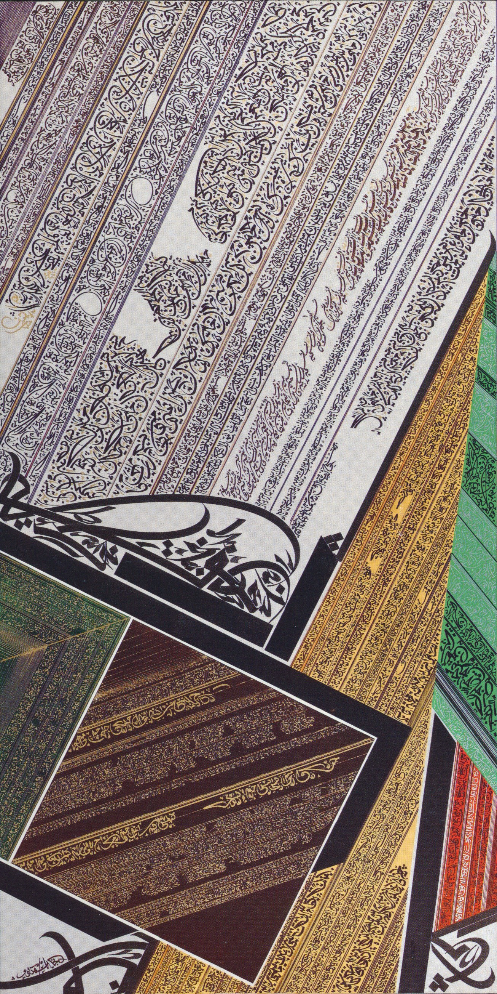

Fig. a. Nja Mahdaoui, *Jorf I*, 2007. India ink, acrylic, gold and silver on canvas, 200cm x 100cm. Image courtesy of Galerie el Marsa.

**References and further reading:**

Butor, M. and Ben Cheikh, J. (1988) *Écritures: Rachid Koraïchi, Mehdi Qotbi, Nja Mahdaoui*, Tunis: Simpact.

Chelbi, M. (2002) *La Quête de la Tunisianité*, Tunis: Finzi.

Issa, R. (1995) *Signs, Traces, Calligraphy: Five Contemporary Artists from North Africa*, London& Amsterdam: Concourse Gallery; Barbican Centre; Tropenmuseum KIT.

Issa, R. and Nazarli, M. (2007) *The Dance of Pen and Ink: Contemporary Art of the Middle East*, St. Petersburg: Gosudarstvennyi Ërmitazh.

Kabbani, N. et. al. (2000) *Noon*, Tunis: Simpact Editions.

Louati, A. (1997) *L’aventure de l’art moderne en Tunisie*, Tunis: Simpact Editions.

Maunick, E. and Madani, E. (1983) *Nja Mahdaoui*, Tunis: Cérès Productions.

Porter, V. and Caussé, I. (2006) *Word Into Art: Artists of the Modern Middle East*, London: British Museum Press.

Shabout, N. (2010) ‘The Arabic Connection in Articulating North African Modernity in Art’, *South Atlantic Quarterly* 109(3): pp. 529-542.

Vílchez, J. and Mahdaoui, N. (2010) *Libertad e innovación: caligrafía árabe contemporánea*, Madrid: Turner; Casa Árabe.

List of Works:

Mahdaoui, N. (2001) *L’art Calligraphie*, Tunis: l’Or du Temps.

Mahdaoui, N. (1992) ‘Transmutation et presence dans l’ œuvre de Paul Klee’, in *Villes dans l’Imaginaire: Marrakech, Tunis, Alger*, Köln: Cahier d’Etudes Maghrébines/Zeitschrift für Studien zum Maghreb: 94-99.

Mahdaoui, N. and Ben Cheikh, J. (2001) *La Volupté d’en mourir*, Paris: Editions Alternatives.

Mahdaoui, N. and Titch, K. (2013) *Kun*, Tunis: Simpact Editions.

Mahdaoui, N. and de Zayas, R. (2004) *Le Maître d’amour*, Paris: Albin Michel.

Stétié, S. and Mahdaoui, N. (2000) *Badr Chaker es-Sayyâb: Les poems de Djaykoûr*, Fata Morgana.